**MODULE- III**

**DIVERSION HEAD WORKS:** Location of diversion head works – Components – Causes of failure of weirs and remedial measures – Bligh’s and Khosla’s theories of design of weirs and permeable foundation.

Objective:

An irrigation canal takes its supplies from a river or a stream. In order to divert water from the river into the canal it is necessary to construct certain works or structures across the river and at the **head of the offtaking** canal. These works are known as **canal headworks** or **headworks.**

The canal headworks may be classified into the following two types:

1. Storage headworks
2. Diversion headworks

**TYPES OF DIVERSION HEADWORKS**

1. Temporary diversion headwork
2. Permanent diversion headwork

**LOCATION OF CANAL HEAD WORKS**

1. Rocky stage or Hilly stage
2. Boulders stage
3. Trough stage or Alluvial stage
4. Delta stage

**SELECTION OF SITE FOR CANAL HEADWORKS**

* As far as possible a narrow, straight, well defined channel confined between banks not submerged by the highest flood should be selected.
* It should be possible to align the offtaking canal in such a way that the command of its area is obtained without excessive digging.
* The material construction such as stone, sand etc., should be available in the vicinity of the site.
* The site should be accessible by rail or road. Also suitable site for the location of the colony for the workers should be available in the vicinity of the project site.

**COMPONENTS OF THE DIVERSION HEADWORKS**

The various components of diversion headworks are as follows

1. Weir or Barrage
2. Divide wall or Divide groyne
3. Fish ladder
4. Pocket or Approach channel
5. Undersluices or Scouring Sluices
6. Silt Excluder
7. Canal Head regulator
8. River training works such as Marginal bunds and Guide bunds.

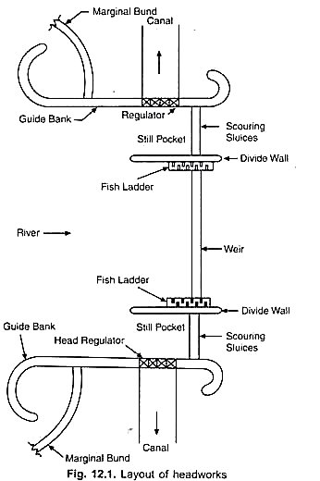

**CAUSES OF FAILURE OF WEIRS ON PERMEABLE FOUNDATION AND THEIR REMEDIES**

The various causes of failure of the weir on permeable foundations may be classified into the two braod categories as follows

1. **Due to seepage or surface flow**
2. **By Piping or undermining**

If the water percolating through the foundation has sufficient force when it emerges at the downstream end of the impervious floor it may lift up the soil particles at the end of the floor. With the removal of the surface soil there is further concentration of flow into the resulting depression and more soil is removed. This process of erosion progressively extends backwards towards the upstream side and results in the removal of soil and developing pipe like formation beneath the floor. The floor may subside in the hollows so formed and fail which is known as failure due to piping or undermining.

The following measures may be taken to prevent the failure due to piping or undermining.

1. Providing sufficient length of the impervious floor so that the path of percolation is increased and exit gradient (i.e., hydraulic gradient at exit) is reduced.
2. Providing piles at the upstream and the downstream ends of the impervious floor.
3. **By uplift pressure**

The water percolating through the foundation exerts an upward pressure on the impervious floor. This pressure is known as uplift pressure. If the uplift pressure is not counterbalanced by the weight of the floor, it may fail by rupture.

The following measure may be taken to prevent the failure of the floor by rupture due to excessive uplift pressure.

1. Providing sufficient thickness of the impervious floor.
2. Providing pile at the upstream end of the impervious floor so that the uplift pressure is reduced on the downstream side. The surface flow may cause the failure of a weir in the following two ways.
3. **Due to surface flow.**
4. **By suction due to standing wave or hydraulic jump**

The standing wave or hydraulic jump developed on the downstream side of the weir causes suction or negative pressure which also acts the direction of uplift pressure. If the floor thickness is insufficient it may fail by rupture due to suction

The following measures may be taken to prevent the failure of the floor by rupture due to suction or negative pressure.

1. Providing additional thickness of the impervious floor to counterbalance the suction pressure due to standing wave.
2. Constructing floor as monolithic concrete mass instead of in different layers of masonry.
3. **By scour on the upstream and downstream of the weir**

Both at upstream and downstream ends of the impervious floor the bed of the river may be scoured to considerable depths during floods. If it preventive measures are taken these scours may cause considerable damage to the floor leading its failure.

The following measures may be taken to prevent the failure of the floor due to such scours.

1. Providing deep piles both at upstream and downstream ends of the impervious floor. The piles we to be driven upto a depth much below the calculated scour depth
2. Providing launching aprons of suitable length and thickness at upstream and downstream end of the impervious floor.

**DESIGN OF IMPERVIOUS FLOOR FOR SUBSURFACE FLOW**

In 1895, when Khanki weir was damaged, experiments were carried out by Lt. Col. Clibbron, Principal, Thomason College Roorkee (Present IIT, Roorkee), on flow of water through soils to ascertain the criteria of designing weirs on permeable foundations. The results of these experminets indicated that Darcy’s law was valid for flow through soils under low heads. Further on the basis of he results of these experiments and certain field observations, it is found that the subsurface flow or foundation seepage may cause the failure of an impervious floor on a permeable foundation in two ways viz.,

1. Piping and
2. Uplift pressure

Some of the notable contributions for obtaining the solution of this problem are those of **Bligh, Lane and Khosla.**

**BLIGH’S CREEP THEORY**

In 1910 W.G. Bligh presented a theory for the subsurface flow in his book ‘Practical design of Irrigation Works’. This theory came to be known as Bligh’s Creep Theory.

**Assumptions :**

1. *‘The percolating water creeps along the base profile of the structure which is in contact with the subsoil.’*
2. *‘The head loss per unit length of creep which is called* ***hydraulic gradient*** *is constant throughout the percolating passage.’*

***Length of creep or creep length : The length of the path traverse by the percolating water.***

From this it follows that ***‘the loss of head is proportional to the length of creep.’***

Bligh made no distinction between horizontal and vertical creep.

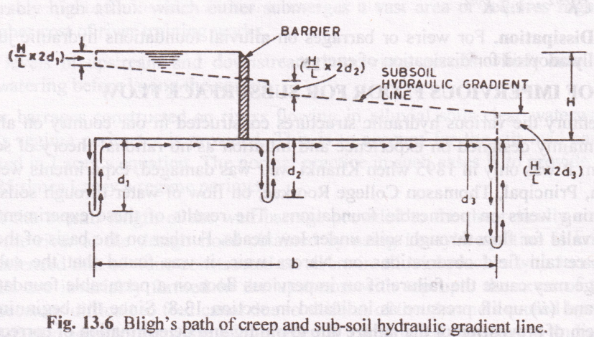

FIG. 3.1 Bligh’s path of creep and sub-soil hydraulic gradient line

From Fig 3.1., consider a barrier impounding water depth H, which is provided with a horizontal floor of length b with three vertical cutoffs as shown. The percolating water will then follow the path indicated by arrows and the creep length L will be given by

L = b + 2d1 + 2d2 + 2d3

The hydraulic gradient or the loss of head per unit length of creep will therefore be given by

$\frac{H}{L}$ = $\frac{H}{b+ {2d}_{1}+ {2d}_{2}+ {2d}_{3}}$--------------- (1)

As hydraulic gradient is constant, if L1 is the creep length upto any point, then head loss upto this point will be (H/L)*L1 and the residual head at this point will be [H-(H/L)*L1]. Also there will be losses of head equal to (H/L)2d1, (H/L)2d2, and (H/L)2d3 respectively in the planes of the three vertical cutoffs and the hydraulic gradient line will be drawn as shown in FIG 13.6.

The reciprocal of hydraulic gradient i.e., (L/H) is known as Bligh’s Coefficient of creep C. Thus, L = CH ---------------------- (2)

According to the Bligh, to ensure the safety of the impervious floor against the two possible ways in which failure may be caused by surface flow, following criteria are required to be satisfied.

1. Safety against piping: the length of creep should be sufficient to provide a safe hydraulic gradient according to the type of soil.

i.e., L = CH

Bligh has recommended certain values of C for different soils as given in Table 3.1

The hydraulic gradient (H/L) is then equal to (1/C) and according to Bligh if the hydraulic gradient ≤(1/C) there will be no danger of piping.

**TABLE. 3.1 : Recommended values of Bligh’s coefficient of creep C and safe hydraulic gradient**

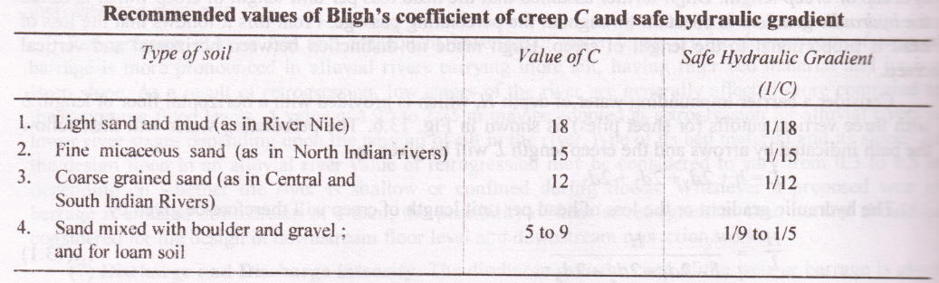

1. Safety against uplift pressure: the ordinate of the subsoil hydraulic gradient line above the bottom of the floor at any point represents the residual seepage head or the uplift pressure at that point. Thus if at any point h’ is the ordinate of the hydraulic gradient line above the bottom of the floor then at that point the uplift pressure exerted by the percolating water is wh’, where w is specific weight of water. If at this point the floor thickness is t and the specific gravity of the material of the floor is G, the downward force per unit area due to the weight of the floor is (wG)t.

For equilibrium the uplift pressure must be counter balanced by the weight of the floor. Thus equating the two, we get

wh’ = (wG) t

t = $\frac{h'}{G}$---------------- (3)

However, the ordinate h’ of the hydraulic gradient line above the bottom of the floor can only after the floor thickness has been determined. Thus it is more convenient to express equation (3) in the following form

h’ = tG

Deduct t from both sides

Therefore, h’ – t = t G – t = t (G-1)

From which

t = $\frac{h^{'}-t}{G-1}$------ (4)

or t = $\frac{h}{G-1}$------ (5)

where h = (h’ – t) is the ordinate of the hydraulic gradient line measured above the top of the floor.

Dividing this ordinate by (G-1) i.e., the submerged specific gravity of the floor material, the thickness of the floor may be determined.

The floor thickness given by equation (4) is usually increased by considering a factor of a safety of (4/3) and hence we have

t = $\frac{4}{3}\frac{h}{G-1}$

it may be noted that on the U/S side of the barrier which holds up the water and creates the seepage head, the uplift pressures are counterbalanced by the weight of the water standing on the floor. However, when there is no water on the U/S side of the barrier there will be no seepage head and no uplift pressure. As such for the U/S floor only a nominal thickness needs to be provided to resist wear, impact of the flowing water or development of cracks. The floor of the D/S side of the barrier must be designed in accordance with equation (4).

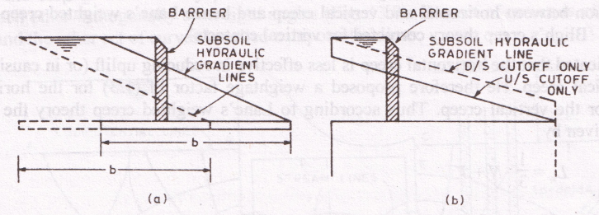

As the upstream floor needs to be provided with only a nominal thickness as per practical considerations, while the downstream floor has to be designed to resist uplift pressure and is therefore thicker, it would be economical to provide as much of the total required creep length on the upstream of the barrier as possible. However, a minimum floor length is always required to be provided on the downstream side from the consideration of surface flow to resist the action of fast flowing water wherever it is passed to the downstream side of the barrier. Moreover, the provision of maximum creep length on the upstream side of the barrier also reduces uplift pressures on the portion of the floor provided on the downstream side of the barrier (Fig. a). This is so because a large portion of the total creep having taken place upto the barrier, the residual heads on the downstream floor are reduced. Further as shown in Fig. (b) a vertical cutoff at the upstream end of the floor reduces uplift pressures all over the floor. while a vertical cutoff at the downstream end of the floor increases them. Thus according to Bligh's theory a vertical cutoff at the upstream end of the floor is more useful than the one at the downstream end the floor.

**Limitations of Bligh's creep theory**

The various limitations of Bligh's creep theory are as follows.

1. Bligh made no distinction between horizontal and vertical creep.
2. Bligh's method holds good so long as the horizontal distance between the cutoffs or pile lines is greater than twice their depth.
3. Bligh made no distinction between the effectiveness of the outer and inner faces of sheet piles and short and long intermediate piles. However, later investigations have indicated that the outer face of the end sheet piles are much more effective than the inner ones. Also intermediate sheet piles of length shorter than the outer ones are ineffective except for local redistribution of pressure.
4. Bligh did not indicate any significance of exit gradient. However, it has been established that the safety against piping cannot be obtained by simply considering an average hydraulic gradient but the exit gradient should be kept well below the critical value.
5. According to Bligh the loss of head is proportional to the creep length, but it is not true. Also the actual uplift pressure distribution is not linear but it follows a sine curve.
6. Bligh did not specify the absolute necessity of providing a cutoff at the downstream end of the floor, whereas it is absolutely essential to provide a deep vertical cutoff at the downstream end of the floor to prevent undermining.

**LANE'S WEIGHTED CREEP THEORY**

Lane approached the problem by making a statistical examination of 290 existing structwes pervious foundations and evolved a theory in 1932 which is known as Lane's weighted creep theory. Lane made distinction between horizontal and vertical creep and hence Lane's weighted creep theory in effect may be called 'Bligh's creep theory corrected for vertical contacts'.

Lane indicated that the horizontal creep is less effective in reducing uplift (or in causing loss of head than the vertical creep. He therefore proposed a weightage factor of (1/3) for the horizontal creep against 1.0 for the vertical creep. Thus according to lane's weighted creep theory the weighted amp length Lw is given by

Lw = $\frac{1}{3}$ N +V

Where,

N is the sum pf all the horizontal contacts and all the sloping contacts less than 45o to the horizontal; and

V is the sum of all the vertical contacts and all the sloping contacts greater than 45o to th horizontal.

Further to ensure the safety against piping Lw must not be less than C1H (i.e., Lw ≥C1H) where H is total see[age head i.e., the difference of water levels on the upstream and the downstream; and C1 is an empirical coefficient depending on the nature of the soil. Values of C1 or Lane's coefficient of creep for different kinds of soils are given in Table 3.1 . Further the hydraulic gradient (H /Lw) is then equal to (1/C1) and the safety against piping can be ensured if the hydraulic gradient ≤ (1/C1).

Although Lane's theory is an improvement over Bligh's theory, most of the limitations of Bligh's theory exist in Lane's theory also. Moreover Lane's theory is empirical and lacks any rational basis. As such though Bligh's theory is still being used in the design, Lane's theory is not being used and is having only a theoretical importance.

Table 3.1

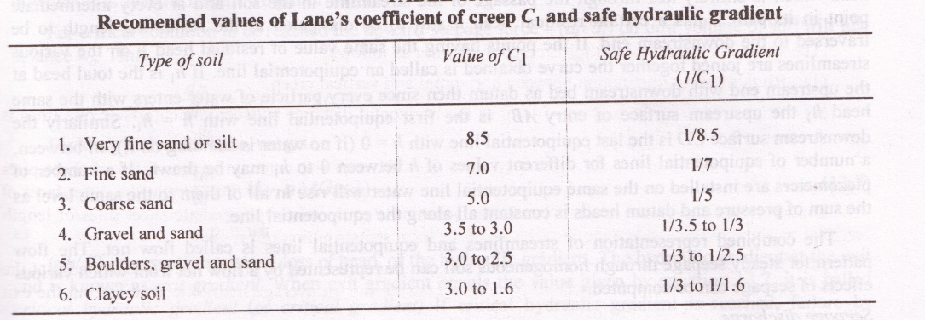

**KHOSLA’S THEORY**

From 1910 onwards Bligh's theory became the accepted basis for designing the structures on permeable foundations. A number of important structures were designed on the basis of this theory, some of which remained stable while others gave trouble or failed. In 1926-27 some siphons on Upper Chenab Canal which were designed on the basis of Bligh's theory had undermining trouble. During investigations the actual pressure measurements were made with the help of pipes inserted in the floors of these siphons, which indicated that the actual pressures were quite different from those computed on the basis of Bligh's theory. These investigations were carried out by Dr. A. N. Khosla and his associates which led to the following interim conclusions.

1. The outer faces of the end sheet piles were much more effective than the inner ones and the horizontal length of the floor.
2. The intermediate sheet piles. if smaller in length than the outer ones were ineffective except for local redistribution of pressures.
3. Undermining of floors started from the tail end. If the hydraulic gradient at the exit was rose than the 'critical gradient' for the particular soil, the soil particles would move with the flow of water tins causing progressive degradation of the subsoil, resulting in cavities and ultimate failure.
4. It was absolutely essential to have a reasonably deep vertical cutoff at the downstream end die floor to prevent undermining.

Khosla and his associates carried out further research to find an ultimate solution to the problem thee subsurface flow and provided a complete rational solution of the problem which is known as Khosla’s theory. The results of this research have been published by the Central Board of Irrigation and Power in the Publication No.12 entitled 'Design of Weirs on Permeable Foundations'. A brief discussion of Khosla's theory is presented as follows.

***Khosla’s method of independent variables:***

In this method a composite weir or barrage section is split up into a number of simple standard forms for which mathematical solutions have been obtained. The most useful standard forms are as follows.

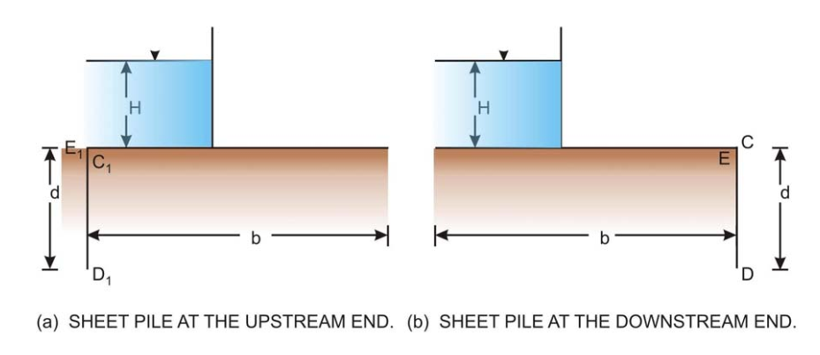

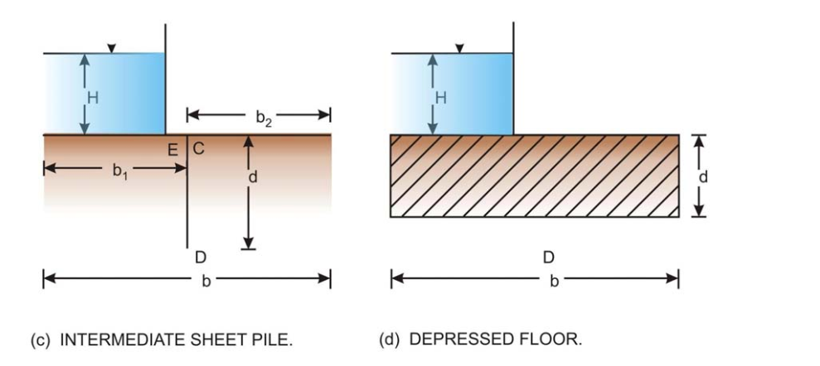

* A straight horizontal floor of negligible thickness with a sheet pile at either end [Figure (a) or (b)].
* A straight horizontal floor of negligible thickness with an intermediate sheet pile [Figure (c)].
* A straight horizontal floor depressed below the bed but with no sheet pile [Figure (d)]

The solution for these simple profiles has been obtained in terms of the pressure head ratio (or percentage) at key points as shown in the figures.

These key points are the junction points of the sheet pile with floor incase of floors of negligible thickness and at the corners of the base at the upstream and down stream end incase of depressed floor. The analytical expressions of each of the above cases are given as under:

* For sheet piles at either upstream end [Figure 6(a)] or the down stream end [Figure (b)].

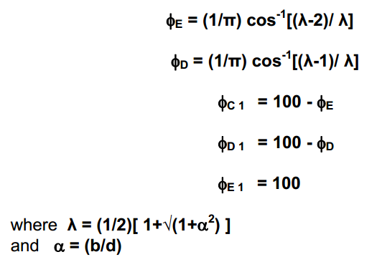

* For sheet piles at the intermediate point [ Figure (c) ]

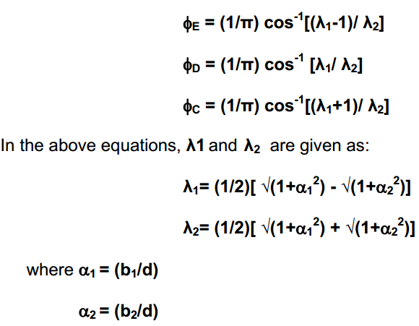

* For the case of a depressed floor

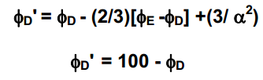

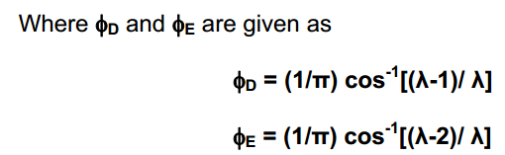

The uplift pressures obtained by the analytical expressions or graphical methods need to be corrected for the following more realistic conditions:

* Floor raft with sheet piles at either end actually has a floor thickness that cannot be considered as negligible compared to the sheet pile depths.
* A floor raft may have sheet piles both at the upstream as well as the downstream ends, which might interfere one with the other.
* The floor of a modern barrage is not horizontal throughout

Some formulas have, therefore, been suggested for incorporating the necessary corrections which are expressed as follows:

***Correction for floor thickness***

Figure illustrates the correction to the evaluated values at key points E and C that is applied considering a floor thickness ***t***.

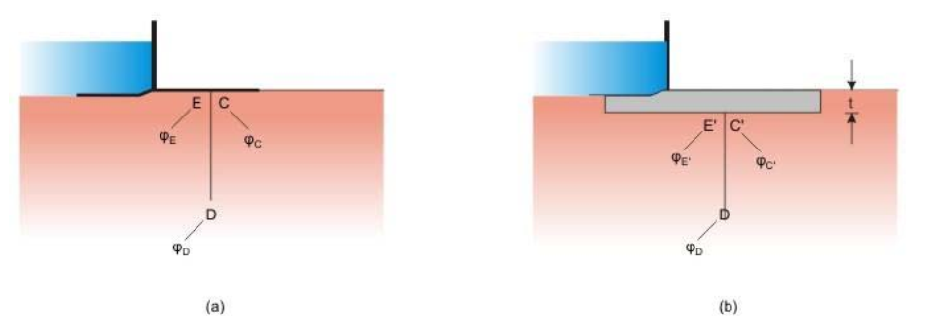

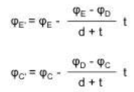



***Correction for mutual interference of sheet piles***Figure gives the amount correction C (in percent) for interference of one sheet pile on the other.

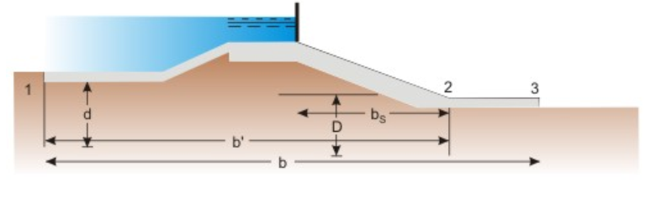

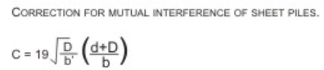

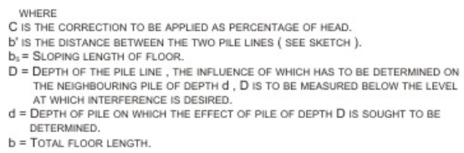

***Correction for slope of the floor***The correction coefficient for taking care of inclined floor is given in Figure (10). The correction coefficients may also be read from the following table:

**Values of slope correction**

|  |  |
| --- | --- |
| Slope(V:H) | Correction of percent of pressure |
| 1:1 | 11.2 |
| 1:2 | 6.5 |
| 1:3 | 4.5 |
| 1:4 | 3.3 |
| 1:5 | 2.8 |
| 1:6 | 2.5 |
| 1:7 | 2.3 |
| 1:8 | 2.0 |

The corrections will have to be taken positive for down slopes and negative for upslopes taken in the direction of flow. The corrections are applicable to the key points of the pile line fixed at the beginning or the end of the slope, for example the pile line 2 at its end E for the floor and sheet-pile shown in Figure 9.

Corresponding to the downstream sheet pile [Figure 6 (b)], the ***exit gradient***, denoted as **GE**, is given below:

The above equation or its equivalent graphical form shown in Figure11 gives a valve of **GE** equal to infinity if there is no downstream sheet pile (d=0). It is, therefore, essential that a downstream sheet pile should invariably be provided for any barrage floor. As mentioned earlier, the calculated exit gradient must not be allowed to exceed the critical value of that of the soil comprising the riverbed material.

